# Assignment-9

1. Write a shell script using if…else to check if a number is even or odd ?

Answers->

* ┌──(kumya㉿sonic)-[~]

└─$ kwrite even_odd.sh

* ┌──(kumya㉿sonic)-[~]

└─$ bash even_odd.sh

1. Explain the difference between if and case statements in bash. ?

Answer->

* IF STATEMENTS
* ┌──(kumya㉿sonic)-[~]

└─$ kwrite if.sh

* ┌──(kumya㉿sonic)-[~]

└─$ bash if.sh

* CASE STATEMENT
* ┌──(kumya㉿sonic)-[~]

└─$ kwrite case.sh

* ┌──(kumya㉿sonic)-[~]

└─$ bash case.sh

1. Write a script to find the largest of three numbers entered by the user. ?

Answer->

* ┌──(kumya㉿sonic)-[~]

└─$ kwrite largest_no.sh

* ┌──(kumya㉿sonic)-[~]

└─$ bash largest_no.sh

1. How do you use a for loop to traverse an array in bash? Give an example. The array is defined as arr=(123, “Abs”, -2.3, ‘A’, 23.56, 0). ?

Answer->

* ┌──(kumya㉿sonic)-[~]

└─$ kwrite arr.sh

* ┌──(kumya㉿sonic)-[~]

└─$ bash arr.sh

1. Write a shell script to loop through all files in the current directory and display their names. ?

Answer->

* ┌──(kumya㉿sonic)-[~]

└─$ kwrite file.sh

* ┌──(kumya㉿sonic)-[~]

└─$ bash file.sh

1. What is the difference between while and until loops in bash ?

Answer->

* WHILE
* ┌──(kumya㉿sonic)-[~]

└─$ kwrite while.sh

* ┌──(kumya㉿sonic)-[~]

└─$ bash while.sh

* UNTIL
* ┌──(kumya㉿sonic)-[~]

└─$ kwrite until.sh

* ┌──(kumya㉿sonic)-[~]

└─$ bash until.sh

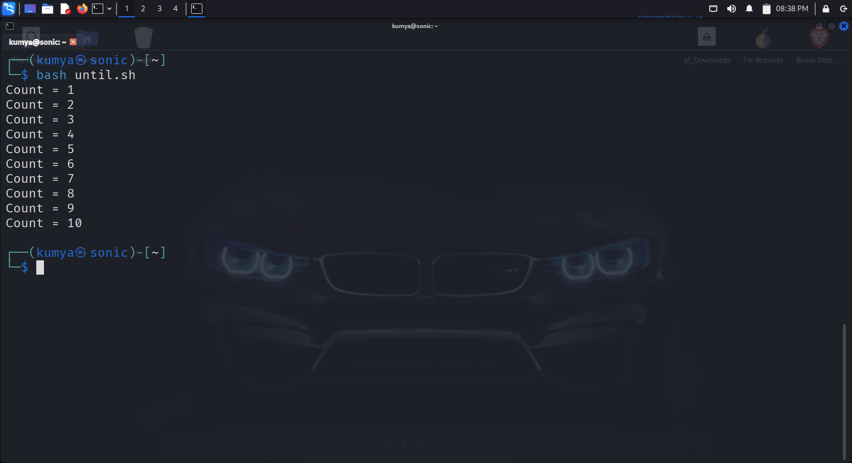

1. Write a countdown timer script using a while loop. ?

Answer->

* ┌──(kumya㉿sonic)-[~]

└─$ kwrite count_down.sh

* ┌──(kumya㉿sonic)-[~]

└─$ bash count_down.sh

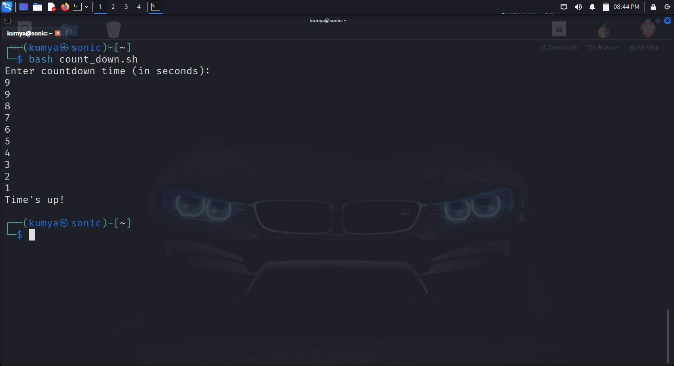

1. How do you use break and continue statements in loops? Give examples. ?

Answer->

* In Bash, **break** and **continue** statements are used to control the flow of loops such as for, while, and until.
* ->BREAK
* ┌──(kumya㉿sonic)-[~]

└─$ kwrite break.sh

* ┌──(kumya㉿sonic)-[~]

└─$ bash break.sh

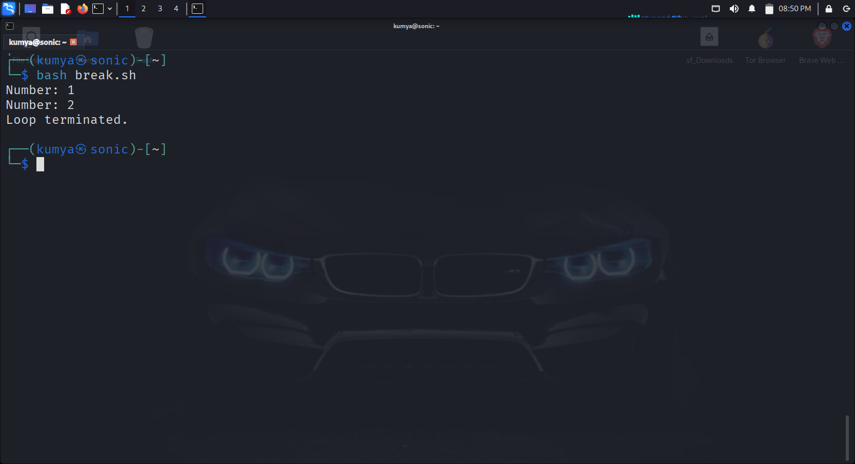

* CONTINUE->
* ┌──(kumya㉿sonic)-[~]

└─$ kwrite continue.sh

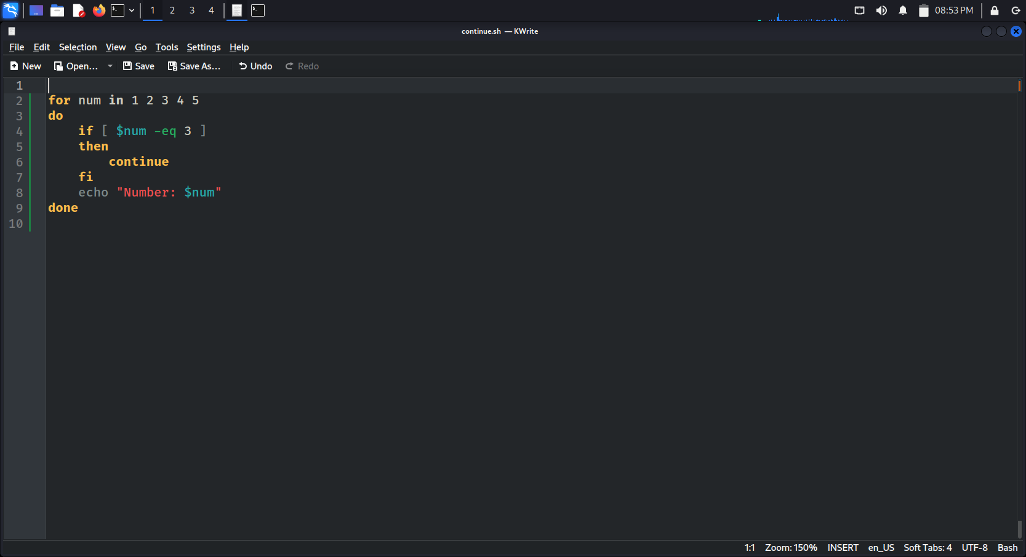

* ┌──(kumya㉿sonic)-[~]

└─$ bash continue.sh

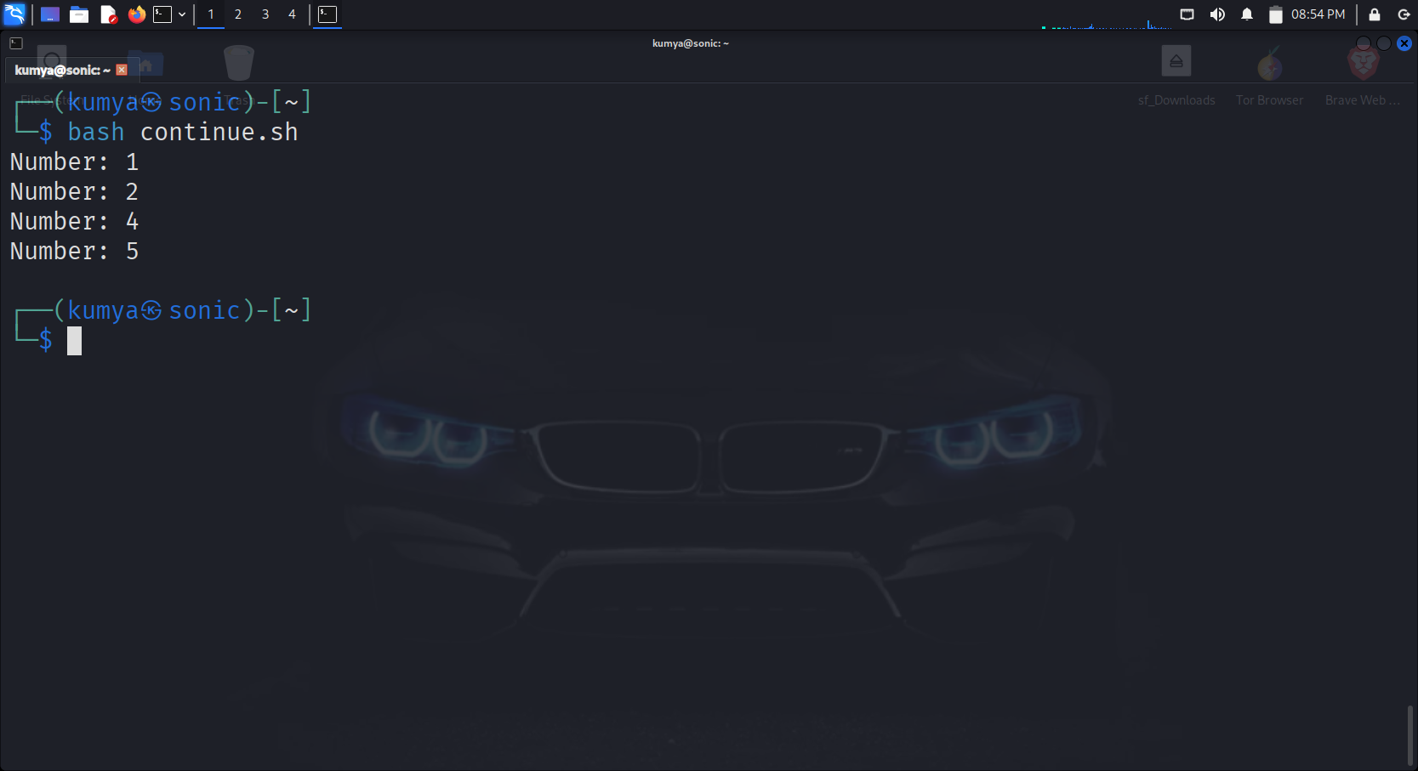

1. Write a script to check if a file exists or not using the if and else loop ?

Answer->

* ┌──(kumya㉿sonic)-[~]

└─$ kwrite file_exists.sh

* ┌──(kumya㉿sonic)-[~]

└─$ bash file_exists.sh

1. Write a script to calculate factorial of a number using for loop ?

Answer->

* ┌──(kumya㉿sonic)-[~]

└─$ kwrite fact.sh

* ┌──(kumya㉿sonic)-[~]

└─$ bash fact.sh

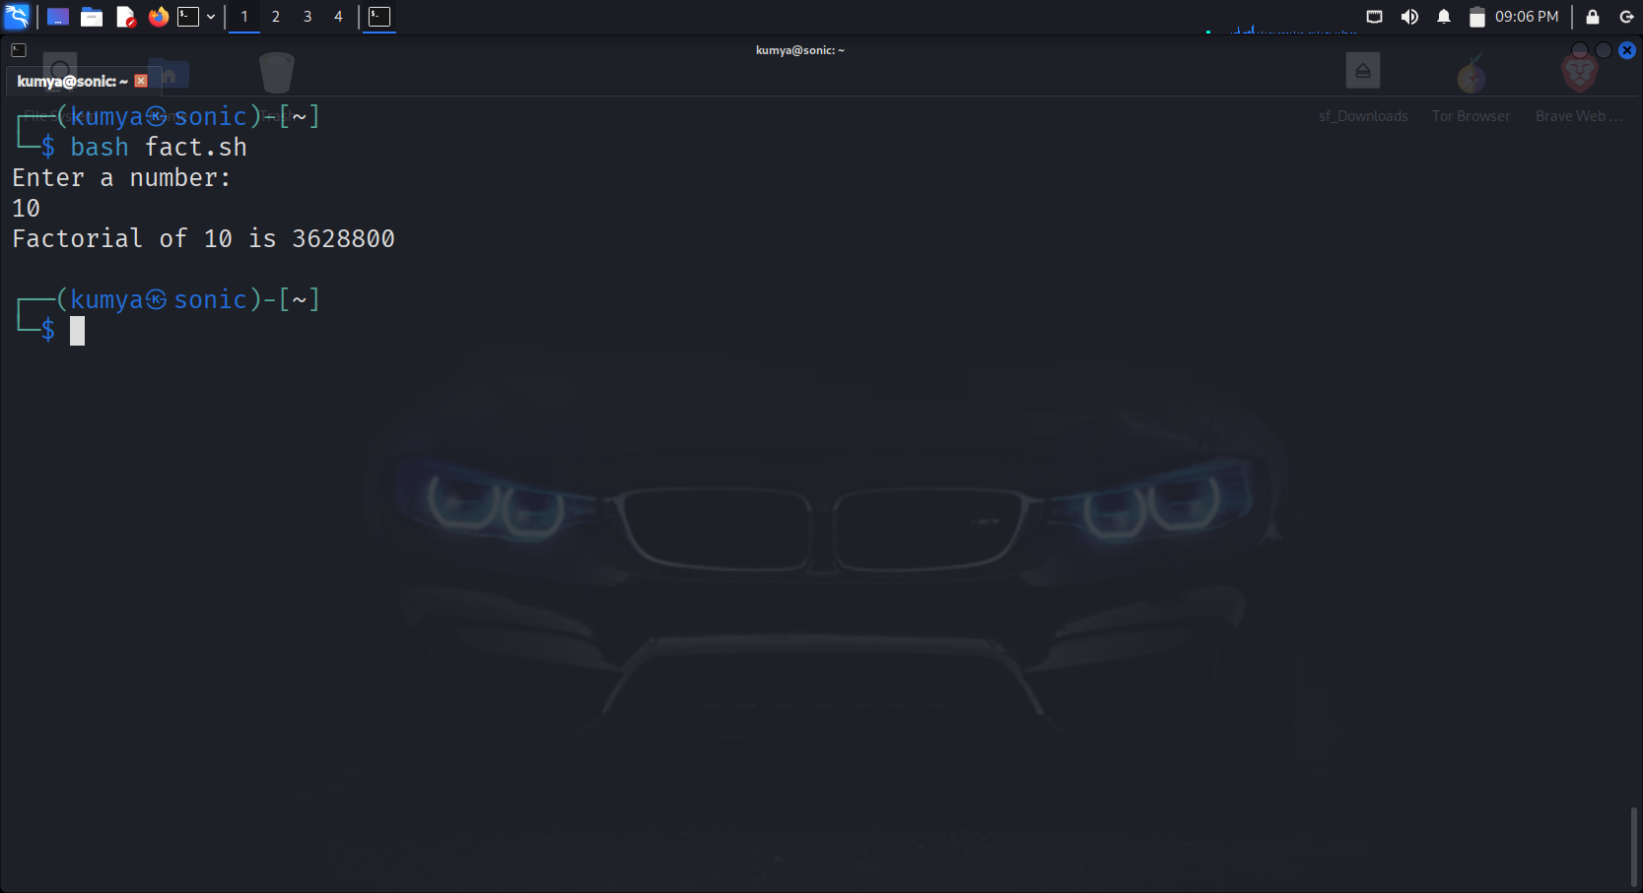

---------------------------------------------------------------END--------------------------------------------------------------